Food Connections conference supports cultural safety and food security in remote communities
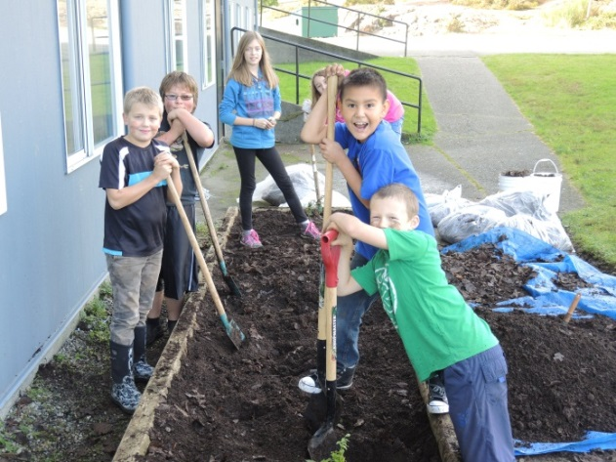
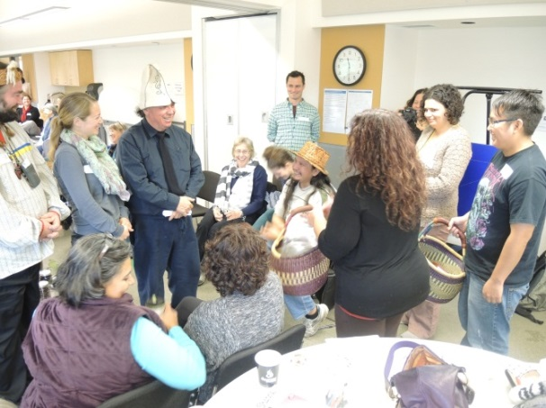
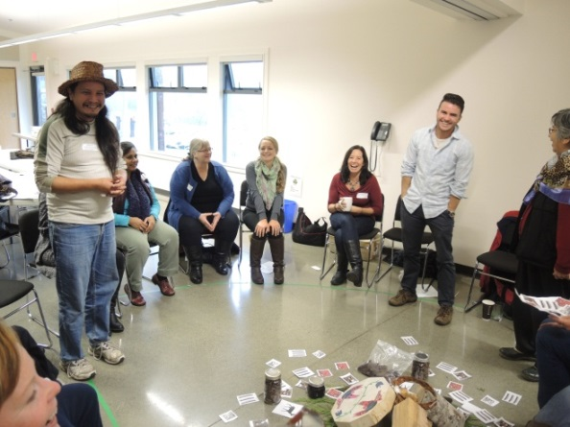
When Aaren Topley¹ signed up for the Food Connections conference in Ucluelet last month, he never expected he’d be getting married to a perfect stranger on his first day. In order to demonstrate goodwill, and sway the daughter of a Chief from a neighbouring territory to marry Aaren, his “home nation” provided hand carved canoes, jars of seal oil, dried mussels, clams, berries, salmon and venison; and a horse and buggy to help the bride visit her home territory whenever she wished.
While all of this was role play, it was a powerful way to illustrate the value of food as a foundation for social, economic, spiritual and physical health among Indigenous peoples of Vancouver Island.
“The relationship between human beings and the water, air, land and every living organism is much like a marriage,” said facilitator John Rampanen, a member of the Nuu-Chah-Nulth First Nation from Ahousaht. “We were taught to be caretakers of their surroundings and every member had a role that contributed to the wellness of their community.” Nations also traded for foods that were not available in their home territory, thus maintaining positive connections with other nations and creating balanced food systems for their populations.
This way of living allowed First Nations to thrive for thousands of years and provided inspiration for remote communities addressing the challenges of food security in 2014. Residents from Tofino, Ucluelet and Port Hardy shared some of the triumphs and trials of living in remote Island communities.
A resident of Port Hardy talked about how they use Facebook to share foods with neighbours who can’t easily access nutritious foods on their own. In Tofino, a group of citizens rallied to multi-purpose their tourism buses to charter residents to towns where they can stock up on necessities that aren’t readily available in Tofino.
“In a city where visitors can spend $100 on a gourmet meal, we still have residents lining up at the Fish & Loaves free-meal service at the community centre,” said Josie Osborn, Mayor of Tofino. To address some of the food gaps, residents created a thriving school-based garden, greenhouse and food program. After the conference wrapped, they put their knowledge into action and led the students and staff at Ucluelet Elementary School as they set up their new greenhouse and garden.
Analisa Blake from Island Health’s Public Health program explains why Island Health is proud to co-sponsor Food Connections “The value of these meetings from a public health and cultural safety lens is significant. The sharing between Island communities creates deeper understanding of food access challenges and the challenges of working on complex social issues like food; the people attending find common ground and form strong connections – they can rely on each other for expertise and bring new knowledge back home – all this helps accelerate change in communities – they have a more advanced starting point, they don’t need to re-invent the wheel, and their work is grounded in strong relationships built on trust and safety.”

